# CMSC 447

### **Software Design and Development**

# (Adapted from Susan Mitchell)

# **User Interface Design Document Template**

Writing Instructions

Use the materials posted under the Writing Resources button on Blackboard as references for grammar, spelling, punctuation, formatting, and writing style.

Be sure that your document is

* Complete - No information is missing
* Clear - Every sentence's meaning must be clear to all parties
* Consistent – The writing style and notation is consistent throughout the document and the document does not contradict itself
* Verifiable - All requirements and other facts stated are verifiable

Remember that you are required to do a team review of this document.

***UMBC Bazaar***

**User Interface Design Document**

#### **Table of Contents**

Page

## Introduction 3

1.1 Purpose of This Document 3

1.2 References 3

1. User Interface Standards 3-4
2. Use Interface Walkthrough 4-14
3. Data Validation 15-16
4. Report Formats 16
5. Appendix A – Agreement Between Customer and Contractor 17
6. Appendix B – Team Review Sign-off 18
7. Appendix C – Document Contributions 19

## 

## 

## **1. Introduction**

Welcome to the UMBC Bazaar user interface design document. UMBC Bazaar is a web application to buy, sell and trade goods or services, which can be thought of as a mixture of Craig’s list, Ebay, and an online services market.

**1.1 Purpose of This Document**

The purpose of this document is to demonstrate to the user how to navigate and interact with the UMBC Bazaar web application. Images will show how the website is interconnected and will display the different pages within the application, and highlighting important features to familiarize users with all that UMBC Bazaar has to offer.

**1.2 References**

1. UMBC Bazaar System Requirements Specification
2. PHP Documentation Group (2016). *PHP Manual*. http://php.net/manual/en/index.php
3. Pressman, R.S. (2010). *Software engineering: A practitioner's approach* (7th ed.). New York: McGraw-Hill Higher Education.

## **2.** **User Interface Standards**

This section contains an overview of the design standards used in the UMBC Bazaar web application. As seen in Figure 1.0 below, there are certain aspects to the UMBC Bazaar layout that are consistent throughout the application. The UMBC Bazaar logo, for example, is contained in the top navigation bar, and shall appear in every page. The UMBC Bazaar logo serves as a hyperlink for users to get access the main page from any page.

## If the user is logged in (Figure 1.0), the top bar also contains the search textbox and button which allows the users to perform a product search on any page by entering a keyword. Furthermore, logged in users will have access to their *My Accounts* and *Logout* buttons. The *My Accounts* page will allow users to access other functionalities reserved for registered accounts such as updating profile, adding or updating products, and viewing orders. The Logout page will invalidate the current session and redirect the user back to the login page.

If the user is not logged in (Figure 2.0), only the UMBC Bazaar logo and some texts are on the top bar. However, the main body will have username, password and login buttons to allow existing users to log in to their account. Also, there is a link to *Reset Password* page and *User Registration* page.

**Figure 1.0: Main Page/ Search Page**

## 

## **3.** **User Interface Walkthrough**

**3.1 UMBC Bazaar Navigation Diagram**

The following navigation diagram explains possible user flow through the system.



**3.2 UMBC Bazaar Walkthrough**

The first page the user will see is the Login page (Figure 2.0). This page will enable the user to access the Home Page once they log in or the Registration page (Figure 2.1) so that they may log in. After logging in, the user will be directed to the Home Page. On this page the user will be able to view their profile, search for items and add items. If the user chooses to search, the results of the search are displayed on the Search Results page (Figure 6) which can then be viewed in more detail on the Product Details (Figure 5.0).

**3.2.1 Logging in**

The login page (Figure 2.0) is accessed every time there is no valid current session. This page contains the username textbox which requires only alphanumeric characters and between 7 to 50 characters long. If the user enter invalid characters, an input listener will remove the invalid characters as the user enters them. The page will display error messages as well as prevent form submission if the criteria are not met (Figure 2.1). Similarly, the password textbox must only be alphanumeric characters plus these special characters !@#$%. Once the username and password are enter, click the login button or hit enter. If the user credentials are valid, the user information will be saved on the session, and the user will be redirect to the main page (Figure 1.0). Otherwise, an error message will be displayed on why the login failed due to invalid credentials or IP address blocking for exceeding the maximum failed attempts (Figure 2.1).

**Figure 2.0: Login Page**  
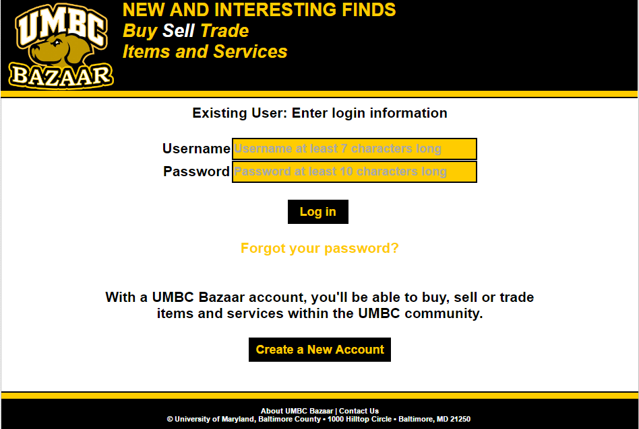

**Figure 2.1: Login Page - Invalid entry**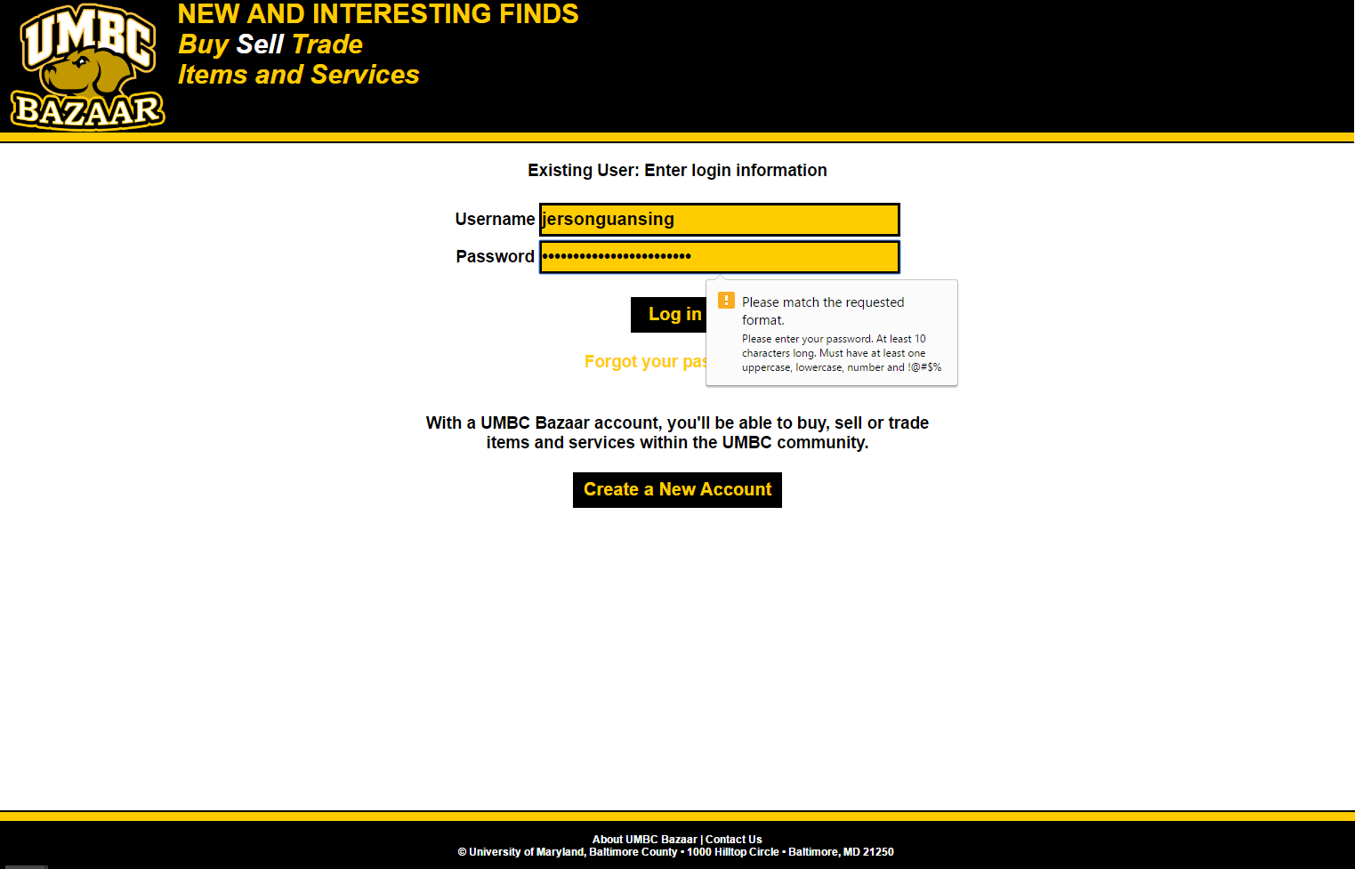

**Figure 2.2: Login Page - Failed Login**

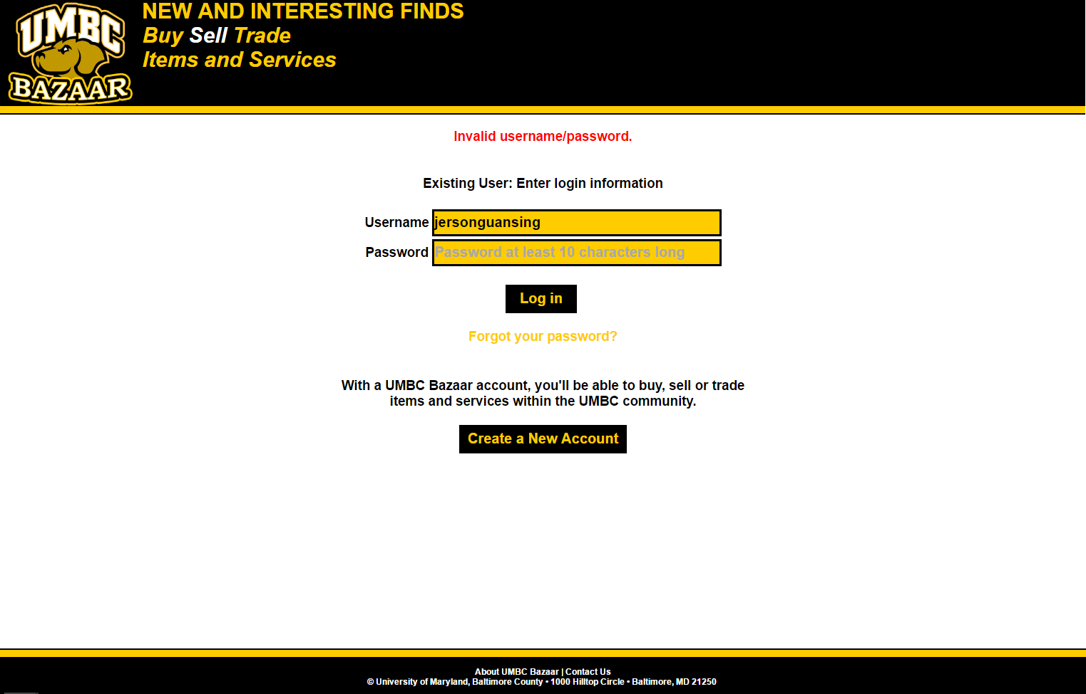

**3.2.2 Resetting password**

The reset password page (Figure 3.0) can be accessed from the link within the login page (Figure 2.0). This allow users to reset their forgotten password, and reset the failed login counter. The web application is designed to block login by IP address that exceeded the maximum login attempts. All the textboxes are required. The page asks for the user’s UMBC ID and username. The UMBC ID textbox entry must meet this format [A-Z]{2}[0-9]{5} for it to be considered valid. Otherwise, the input listeners will display an error and prevent form submission (see Figure 2.1). Similarly, the username must be alphanumeric, and 7 to 50 characters long. In addition, the user must match the string in the captcha image in the third textbox. Once all information are entered, submit by clicking the reset password button or hit enter. If the any of the the user credentials or the captcha string does not match, an error will be displayed (Figure 3.1). Otherwise, an email will be sent to the user’s UMBC email account with the new temporary password. Furthermore, the failed login attempt counter will be reset back to zero (0) and allow users blocked by IP address to relogin.

**Figure 3.0: Reset Password Page**

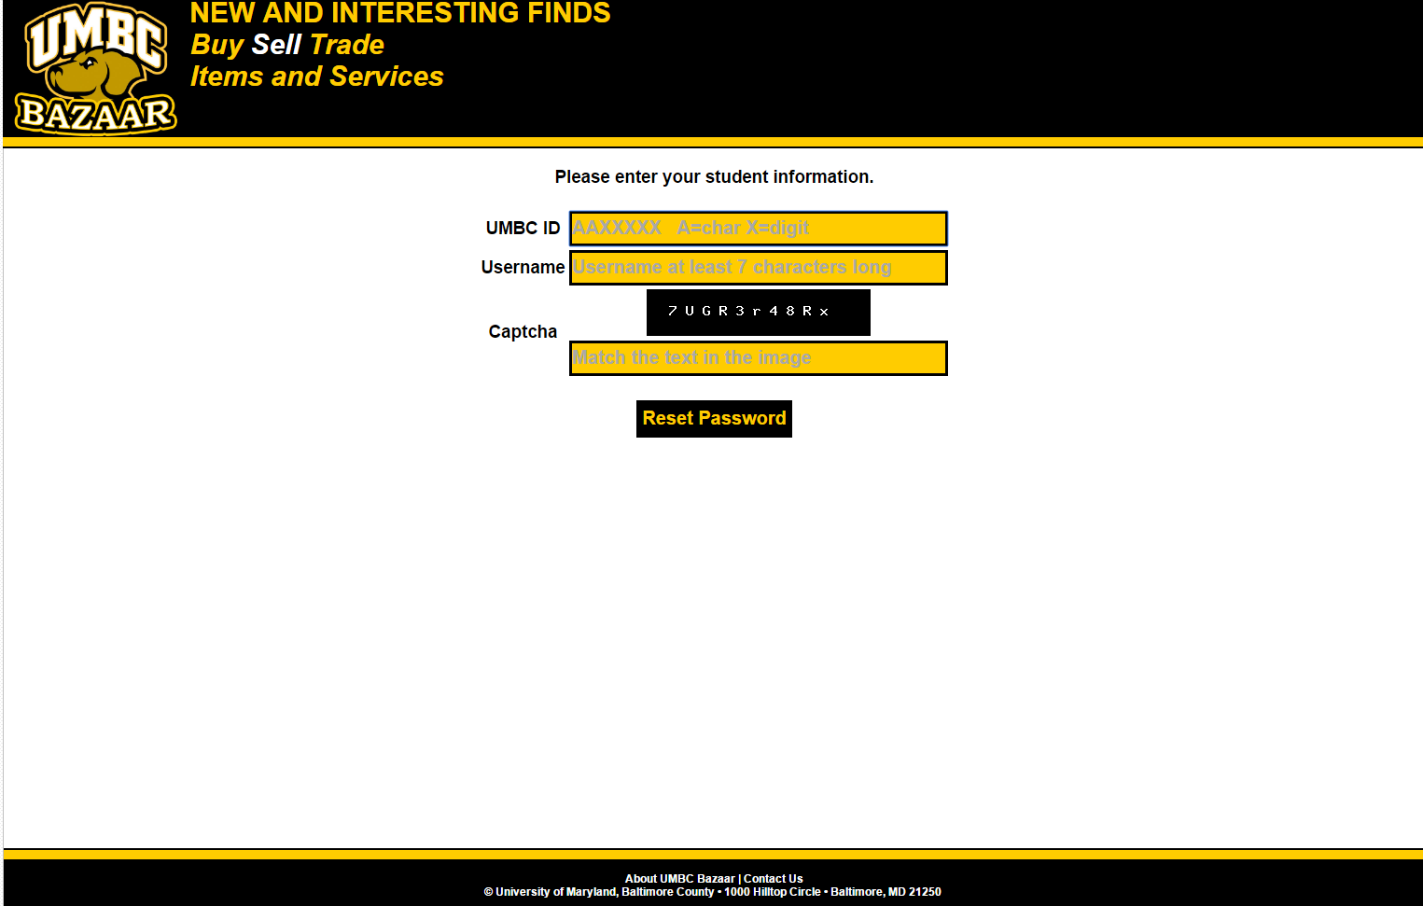

**Figure 3.1: Reset Password Page - Failed Reset**

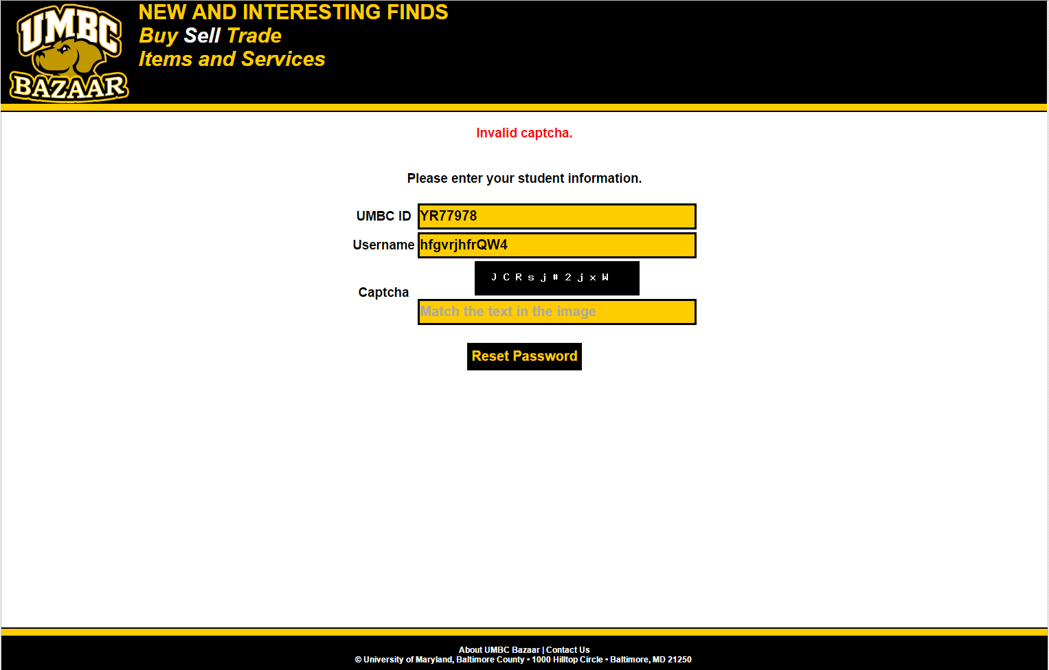

**3.2.3 Registering for an account**

The registration page (Figure 4.0) can be accessed by clicking the “Create a New Account” button within the login page (Figure 2.0). This allow members of the UMBC community to create an account. All the textboxes are required. The page asks for the user’s UMBC ID which must meet this format [A-Z]{2}[0-9]{5} for it to be considered valid. Any invalid characters are automatically removed by the input listener. Once a valid UMBC ID is entered, the page will query the UMBC Directory and fill in the user’s firstname and lastname (essentially enabling these textboxes that are disabled by default). The username, password and reenter password text boxes require the same format validation as previously discussed in the login page section (3.2.1). The password and re-enter password text boxes must match. Furthermore, The user must match the text in the captcha image. Once all the criteria are entered, the user can hit the register button which will either submit the form or display an error message. If any of the fields are invalid then form submission is disabled. Upon a valid form submission, the registration page will authenticate the user criteria on the server-side, and will either display an error message (Figure 4.1) or a confirmation instruction (Figure 4.2). An error can result from invalid captcha, UMBC ID already associated with an account, username already taken etc.. With a confirmation page displayed, the user will be instructed to check their UMBC email and authenticate the registration. Clicking the hyperlink activate the account and display a successful confirmation message (Figure 4.3). The user can now login user their credentials.

**Figure 4.0: Registration Page**

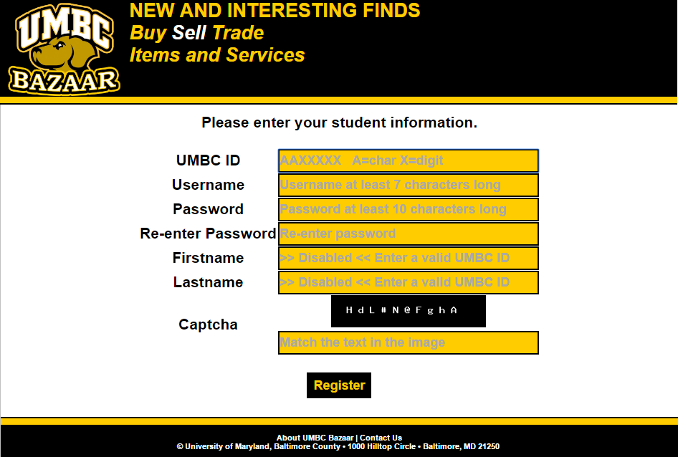

**Figure 4.1: Registration Page - Failed Registration**

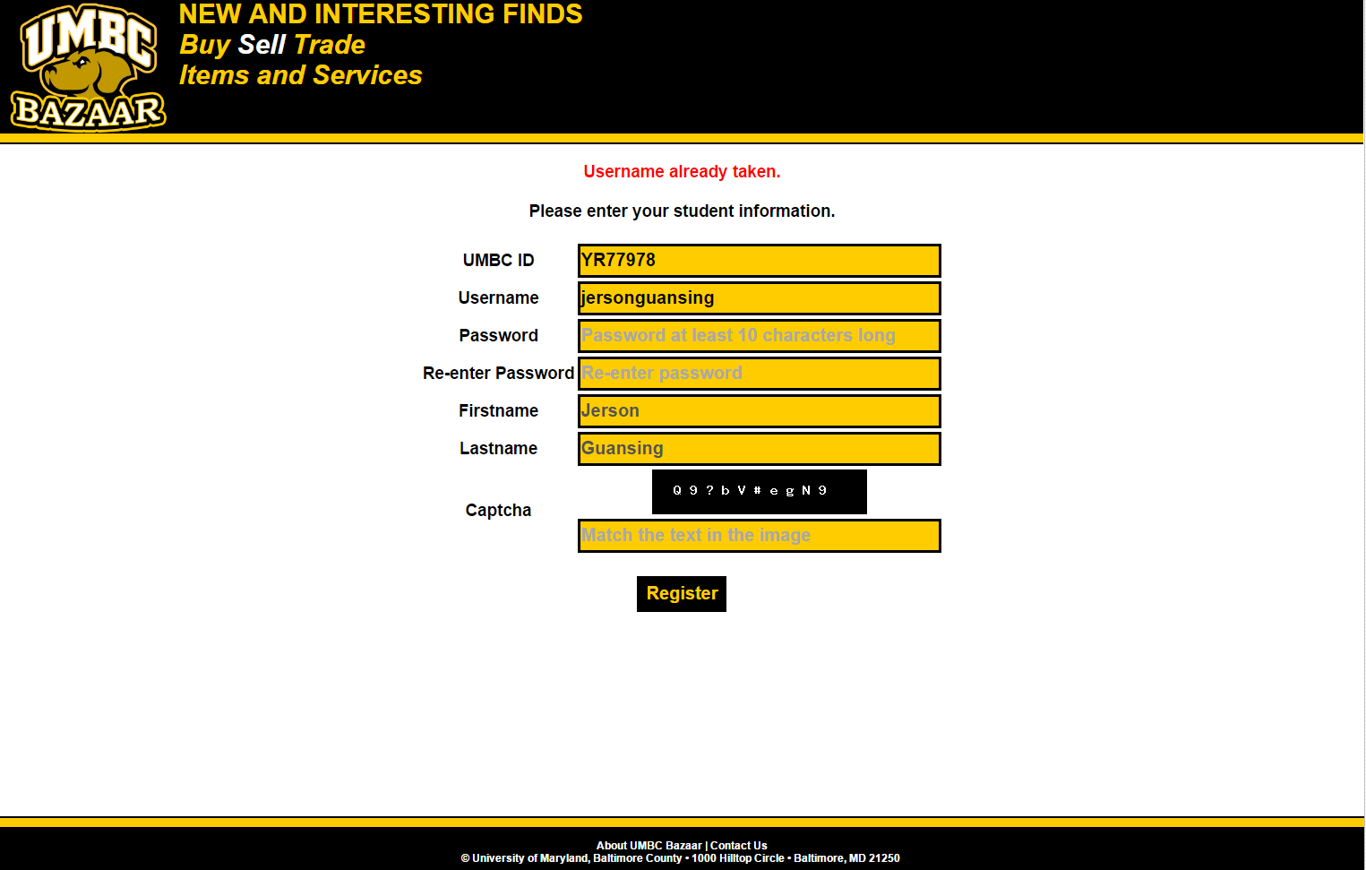

**Figure 4.2: Registration Page - Confirmation Instruction**

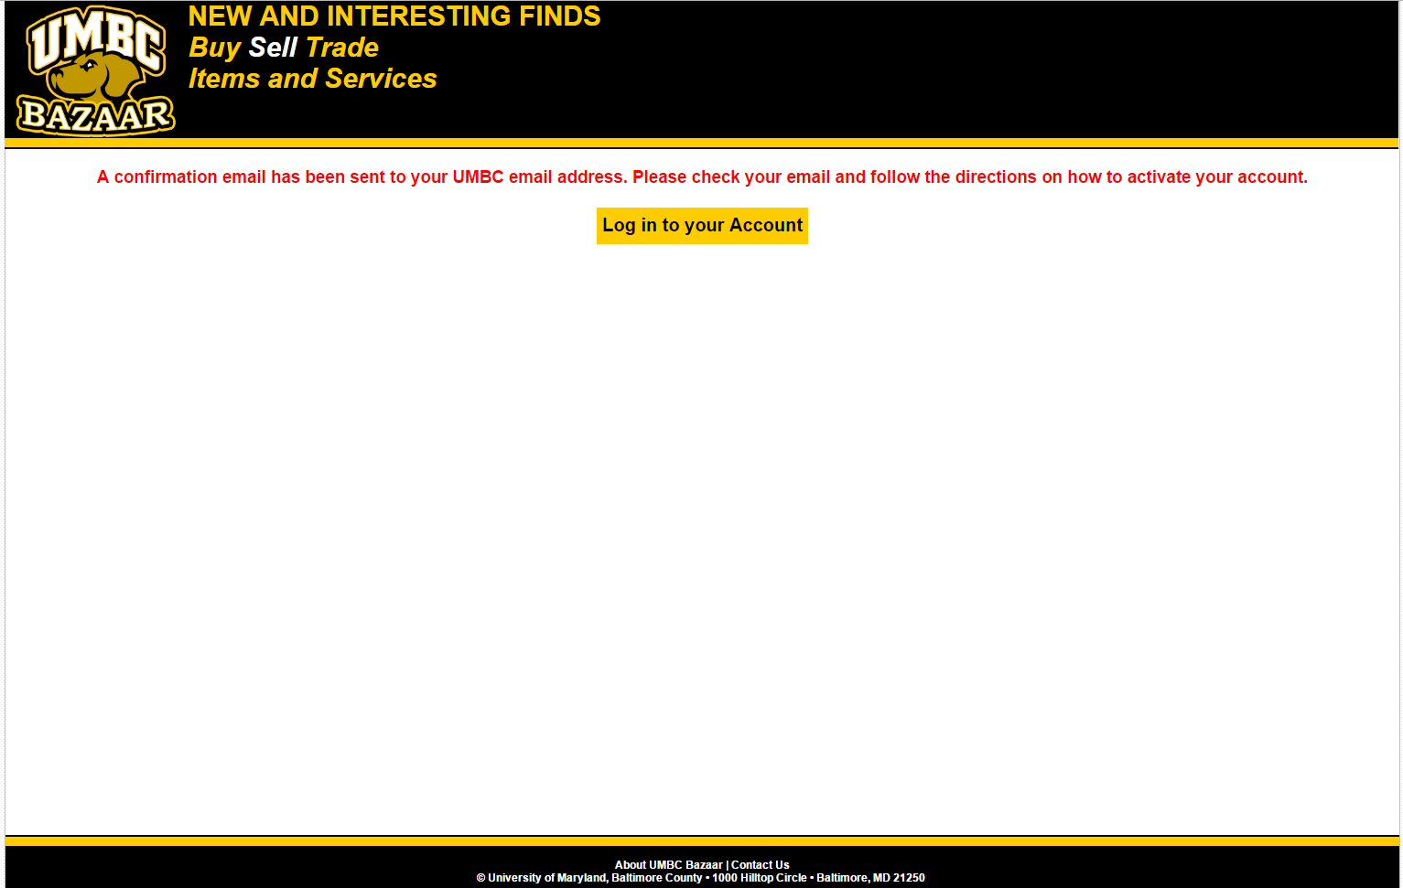

**Figure 4.3: Registration Page - Account Confirmed**

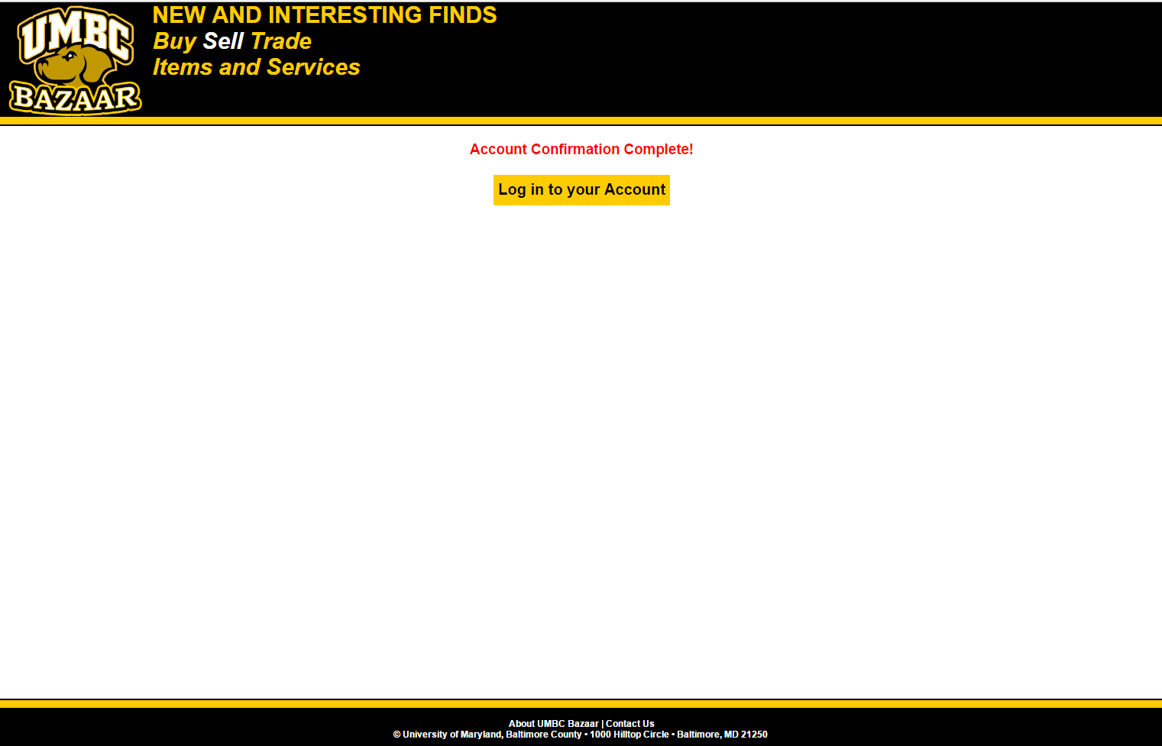

**3.2.4 Adding Products:**

The Products Page (Figure 5.0) can be accessed from the *Home Page* by clicking on the “Sell Product “ button after logging on. This page lists all the products and services, both active and inactive, that you have published. To put products or services up for sale simply click the “Add a New Product or Service” button. This will redirect the user to the Add Product Page (Figure 5.1). Once on the Add Product on Service Page, adding products or services is very simple. To add a new product or service for sale simply input the name of the product or service, check the trade option circle, check the publish circle, add the price, add a description of the product or service, upload an image of the product or service and lastly submit the new product or service. This will allow the user’s product or service to be found in searches. If the user does not wish to put a product or service for sale, the user can return to the previous page by simply clicking the “Go Back to Product/ Service List”. This will redirect the user to the list of Products and Services page.

**Figure 5.0: Add Product Page - List of Products and Services**

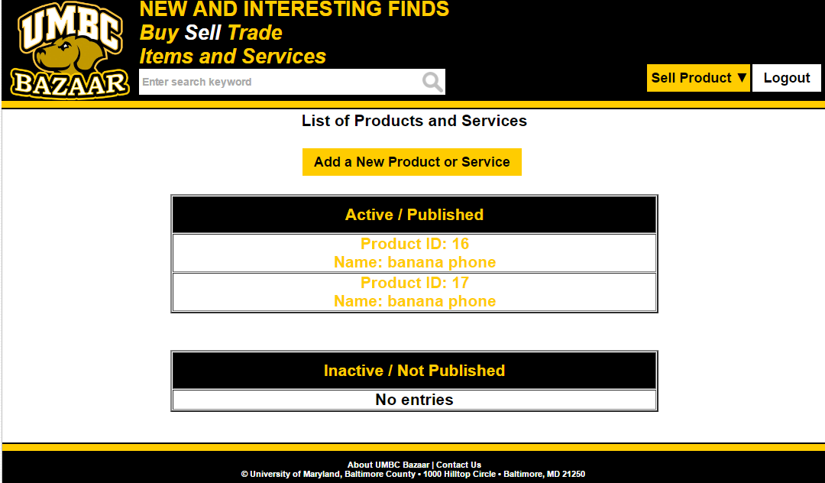

**Figure 5.1: Add Product Page - Add Product or Service**

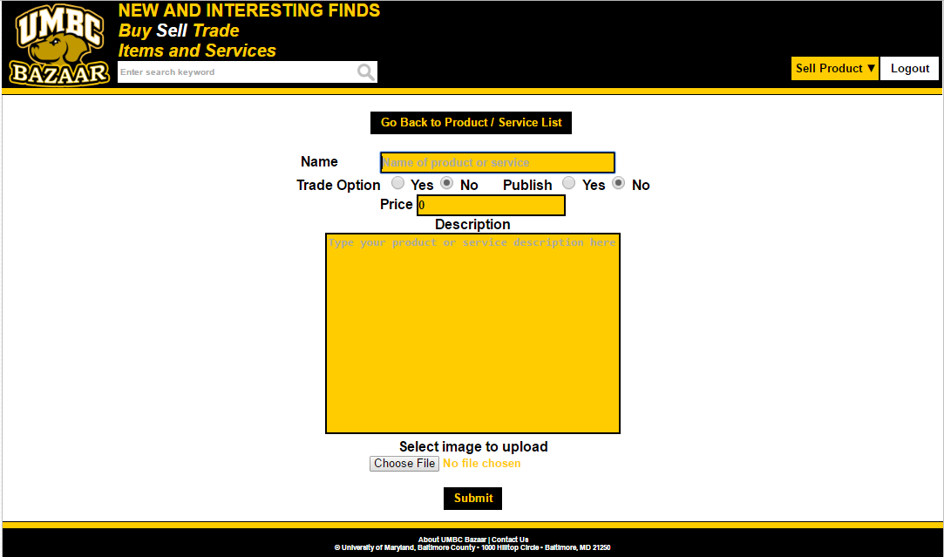

**3.2.5 Buying Products**

In order to buy a product, a user must first search for the product. Using the search bar in the upper left, the Search Results pages are loaded (Figure 6.0 or 6.1). Once a good or service is selected, the user is redirected to the payment page (TBD). The user selects to either trade items, or follow the cash on delivery payment method.

**Figure 6.0: Search Results Page**

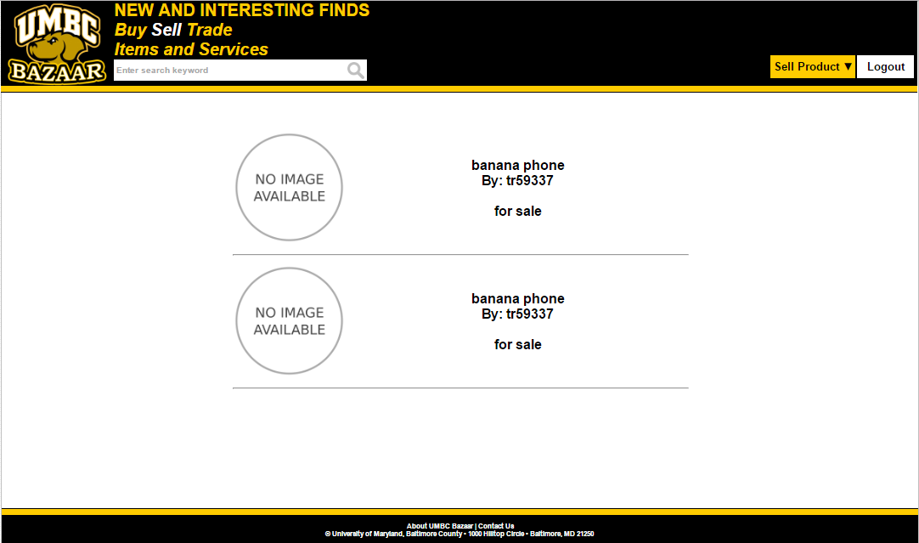

**Figure 6.1: Search Results Page - No Results Found**  
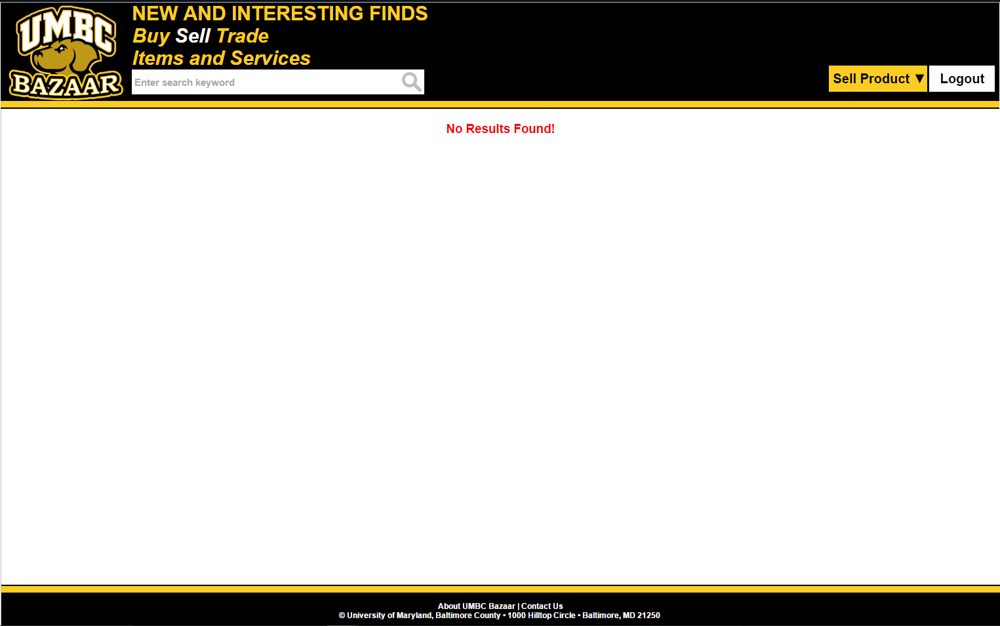

## **4.** **Data Validation**

There are multiple data entry points into the UMBC Bazaar. They include: registering, logging in/out or updating accounts, and searching, adding, updating or buying products. Please refer to the table below for further information regarding allowable inputs, their limits, and allowable formats. In addition all text that is entered is escaped for security and passed to a function to prevent SQL injection.

|  |  |  |
| --- | --- | --- |
| **Entry Location** | **Data Type** | **Limits** |
| UMBC ID | string | Valid ID (UMBC Directory check) and matches the regular expression: [A-Za-z]{2}[0-9]{5} |
| Firstname | string | Retrieved from UMBC Directory services. Alphanumeric only plus spaces. |
| Lastname | string | Retrieved from UMBC Directory services. Alphanumeric only plus spaces. |
| username | string | Alphanumeric only (7-50 characters) |
| password | string | Between 10-50 characters. Matches required strength criteria and passed to an encryption function. At least one uppercase, lowercase, number and one of these special characters !@#$% |
| captcha | string | Matches the captcha image |
| Search: keyword | string | Alphanumeric. Special characters are removed. Limited by the published UMBC Bazaar products. |
| Add product: product name | string | alphanumeric |
| Add product: description | string | Text only. HTML tags are escaped. |
| Add product: trade option | boolean | Yes or No |
| Add product: price | double | Non negative numeric value. |
| Add product: image | Binary image file | Sizeof <= 500 kb  Must be a JPEG, JPG, PNG or GIF. |

## **5.** **Report Formats**

The UMBC Bazaar web application generates no hard copy reports.

**Appendix A – Agreement Between Customer and Contractor**

The client agrees to a *UMBC Bazaar* web application with registering, searching, buying, trading, and other user-based capabilities. Use cases are included in the functional requirements section above of the behavior between the system and user. Additional features will be provided in further development iterations.

When and if future changes to this document occur, a new drafted document shall be created. Both a hard and electronic copy of all versions shall be presented to the client for review. Upon approval, the draft will be finalized and signed off by both the client and contractor.

**Client**

____________________________________ Date:

Ericka Marable

**Team**

_Gene Burchette_______________________ Date: 11/3/2016

Gene Burchette

__Jerson Guansing_____________________ Date: 11/3/2016

Jerson Guansing

____________________________________ Date:

Karl Justice

__DS II__________________________________ Date:

Darren Stevens II

Victor Wu_____________________________ Date: 11/3/2016

Victor Wu

**Appendix B – Team Review Sign-off**

This document has been collaboratively written by all members of the team. Additionally, all team members have reviewed this document and agree on both the content and the format. Any disagreement or concerns are addressed in team comments below.

_Gene Burchette_______________________ Date: 11/3/2016

Gene Burchette

______Jerson Guansing_________________ Date: 11/3/2016

Jerson Guansing

___Karl Justice________________________ Date:

Karl Justice

_DS II_______________________________ Date:

Darren Stevens II

Victor Wu ____________________________ Date: 11/3/16

Victor Wu

## 

## 

## **Appendix C – Document Contributions**

Identify how each member contributed to the creation of this document. Include what sections each member worked on and an estimate of the percentage of work they contributed. Remember that each team member must contribute to the writing (includes diagrams) for each document produced.

Gene: Figure 6.1